Lab 4: Reading from Analog and Encoder Sensors

650:361 Introduction to Mechatronics

Team Members: Shivani Topiwala, Nancy Contreras, and Pamela Pajarillo

**Introduction**

In this lab, we controlled the brightness of an LED using pulse width modulation (PWM) based on the position of the potentiometer using a Simulink Model in the first part. In the second part, we used an encoder to determine the position of the output motor shaft. The brightness of the LED will be controlled based on the position.

**Part 1**

For this section, we had to build and run the given Simulink diagram and change pulse width modulation (PWM) based on the position of the potentiometer in order to control the brightness of an LED.

**Figure 1. Simulink Diagram to Control the Brightness of an LED using PWM**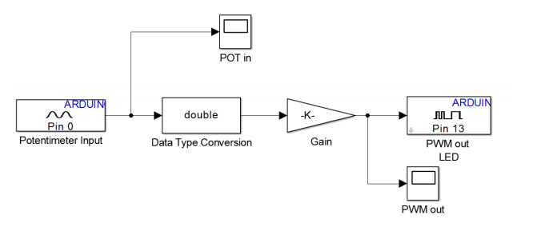

Q1: If the value of the ADC on A0 of the Arduino is 512, what is the input voltage on A0?

We can use the equation $\frac{A/D_{result}{}_{}}{ADC_{resolution}}=\frac{V_{in}}{V_{ref}}$, where $ADC_{resolution}$ is 1023, $V_{ref}$ is 5v, and $A/C_{result}$ is 512. When we plug in all the known values, we get 2.50 v for the input voltage $V_{in}$. We used 5v as the reference voltage because we are assuming that the ADC is operating in a 100% duty cycle.

Q2: What is the correct value for the gain such that the full range of the potentiometer will utilize the full range of the PWM?

Full range of the potentiometer is utilized when gain is 255.

CP1: Observe the scopes while changing the position of the potentiometer wiper. Click the ‘Autoscale’ button to see the full range of the graphs. At what potentiometer wiper position is the LED brightest? At what position of the potentiometer wiper is the LED completely dim?

When gain is 0, the min and max is 0. When gain was 255, the minimum was 770 or 0.0077810^5 and the maximum was 2.6087 *10^5. When gain was 100, the minimum was 100, and the maximum was 1.023*10^5.

**Part 2**

An encoder is a device that can be used to determine position. We used an encoder to determine the position of the output motor shaft, and the brightness of the LED will be controlled based on the position.

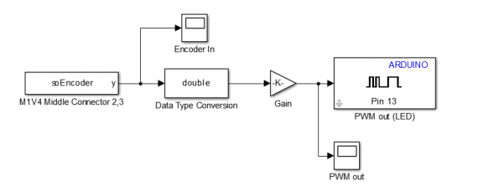

**Figure 2. Simulink Model Used to Control the Brightness of the LED based on the Position**

Q3: What value does the gain need to be so that 1 revolution of the encoder will obtain the maximum value of the PWM? What happens if the motor is turned more than 720? What happens when the encoder position is negative?

With one revolution, when gain is 0, the min and max is 0. When gain was 100, the minimum was 0 and the maximum was 7.21*10^4. When gain was 255, the minimum was 4080, and the maximum was 1.9355*10^5.

With 2 revolutions, when gain was 100, our result was 1.389*10^5, which is around double the value of the max gain for one revolution. When gain was 255, our result was 3.65925*10^5, which is about double the value of the max gain for one revolution. When the encoder position is negative, the LED turns off, and the value that we get is negative.